**Microprocessor and Computer Architecture**

**UE20CS252**

**4th Semester, Academic Year 2021-22**

Date: 24/01/2022

|  |  |  |
| --- | --- | --- |
| Name: Naren Chandrashekhar | SRN: PES2UG20CS216 | Section:  D |

Week#____1_______ Program Number: ____1___

Title of the Program

**Write an ALP using ARM instruction set to check if a number stored in a register is even or odd. If even, store 00 in R0, else store FF in R0**

1. ARM Assembly Code(1)

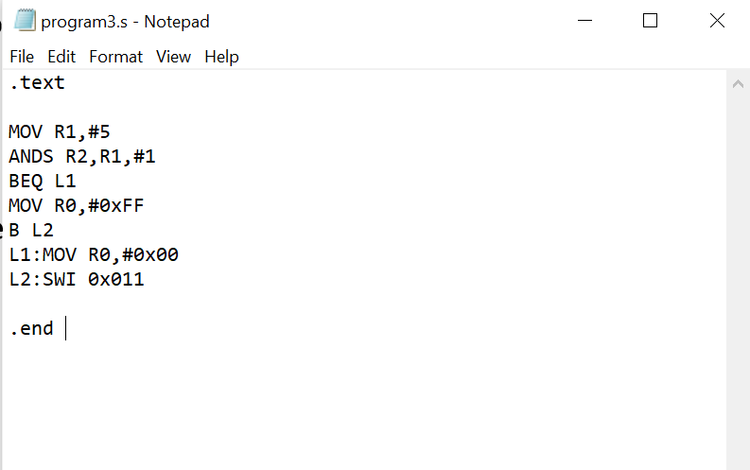

1. Output Screen Shot (1)

The output should be verified for both even and odd numbers.

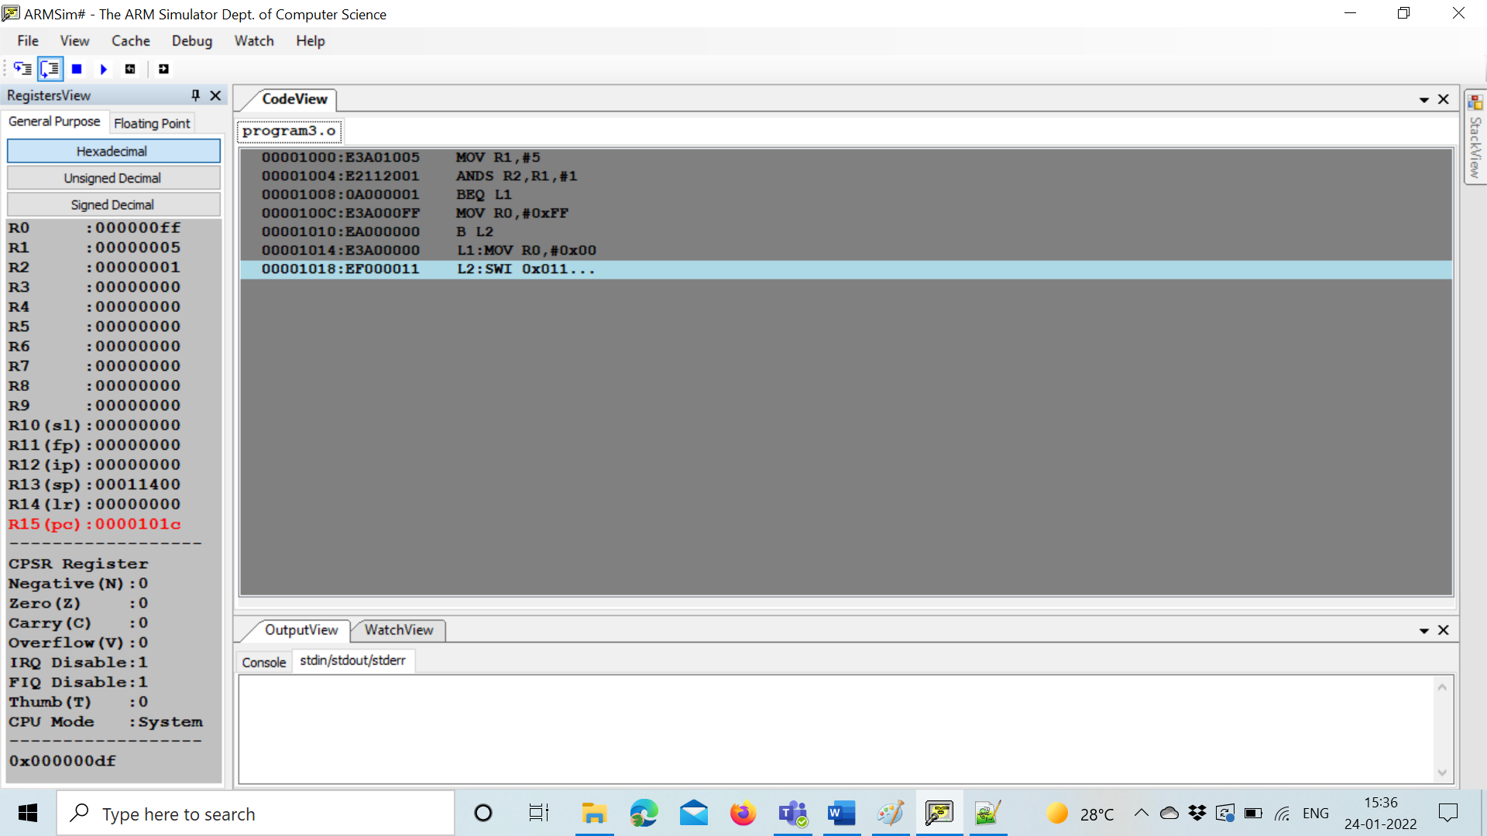

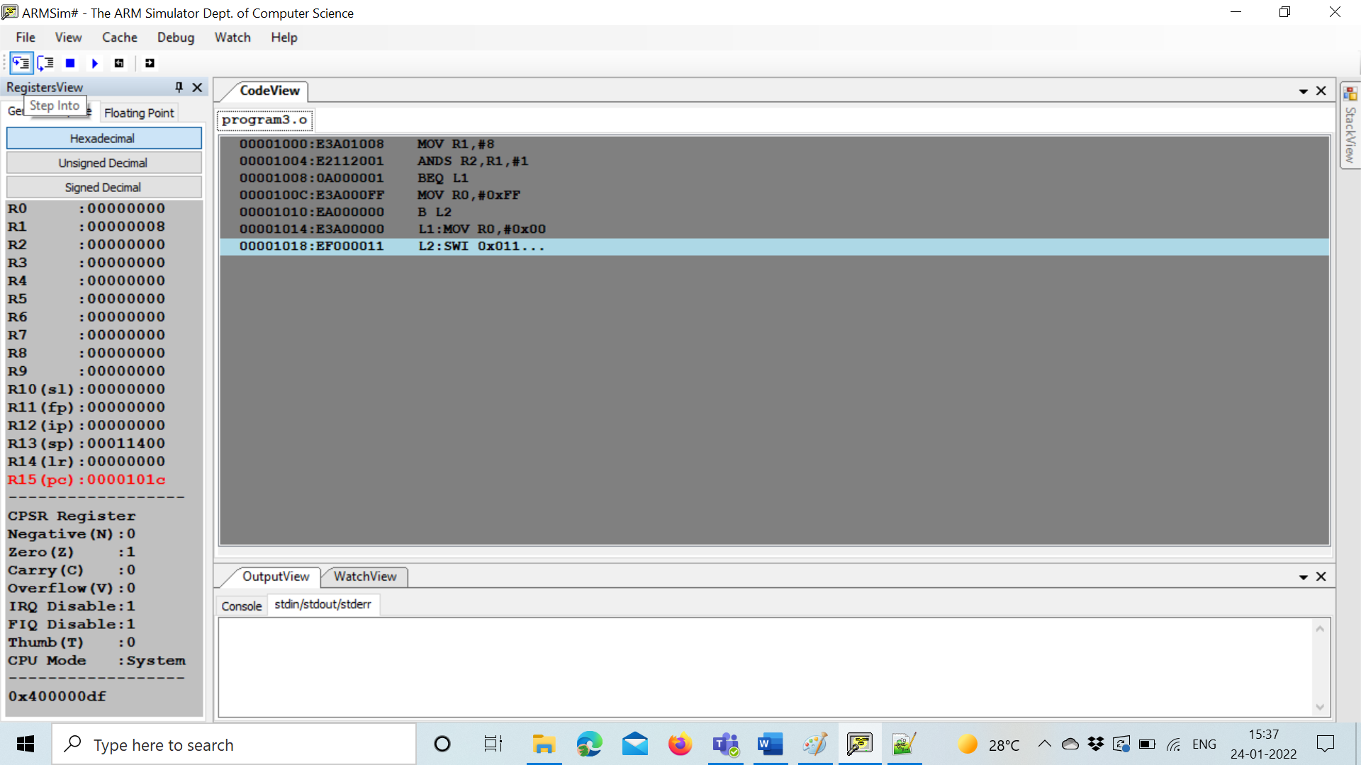

**Microprocessor and Computer Architecture**

**UE20CS253**

**4th Semester, Academic Year 2021-22**

Date:

|  |  |  |
| --- | --- | --- |
| Name: Naren Chandrashekhar | SRN: PES2UG20CS216 | Section  D |

Week#____1_______ Program Number: ____2___

Title of the Program

**Write an ALP to compare the value of R0 and R1, add if R0 = R1, else subtract**

**I.** ARM Assembly Code(1)

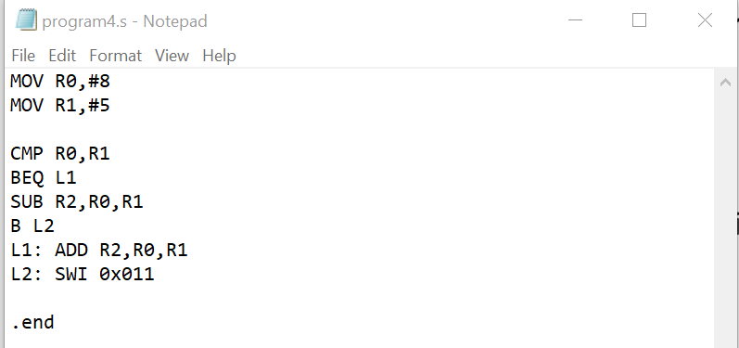

1. Output Screen Shot (1)

The output should be verified for both even and odd numbers.

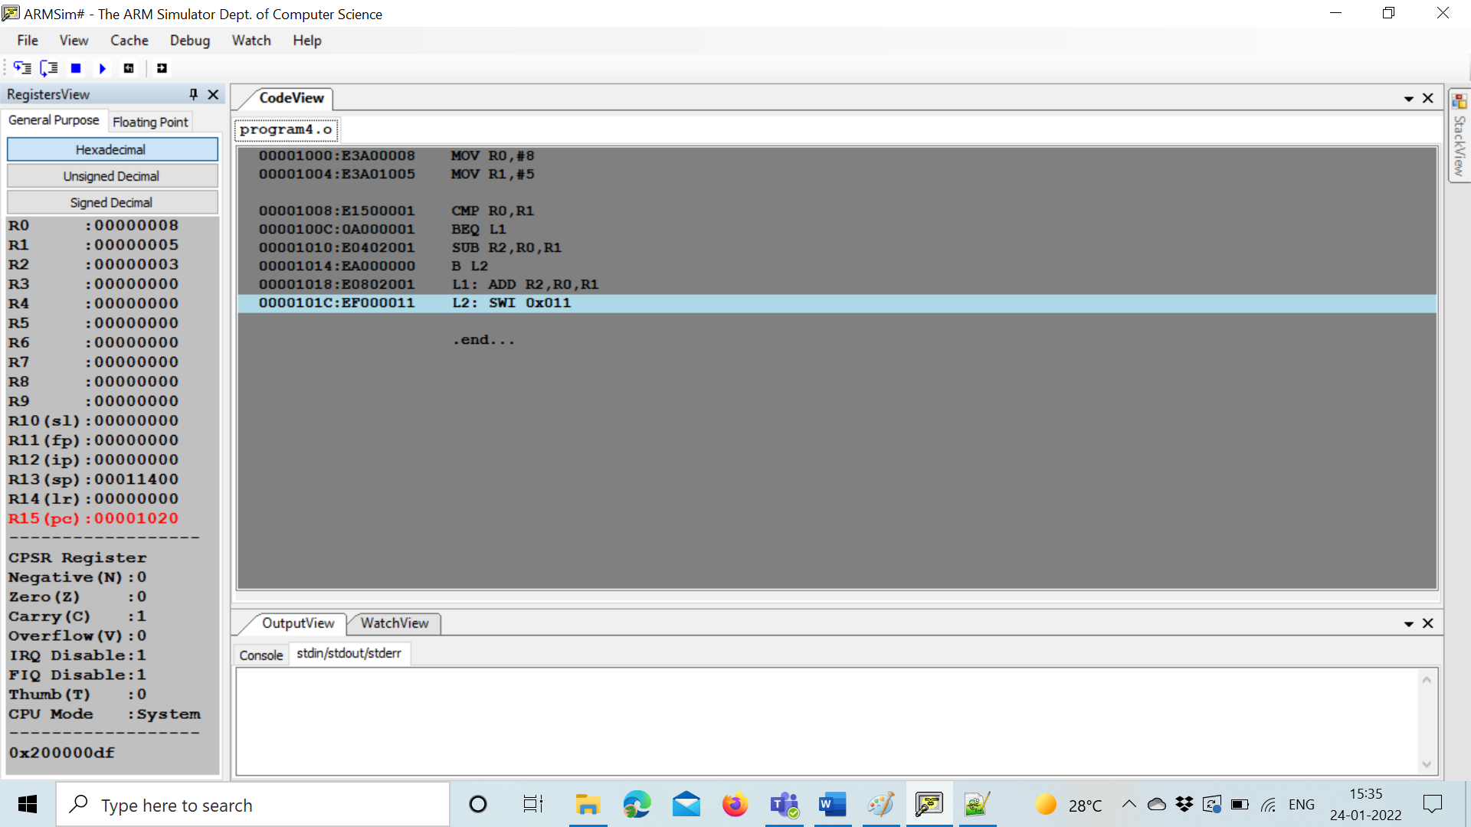

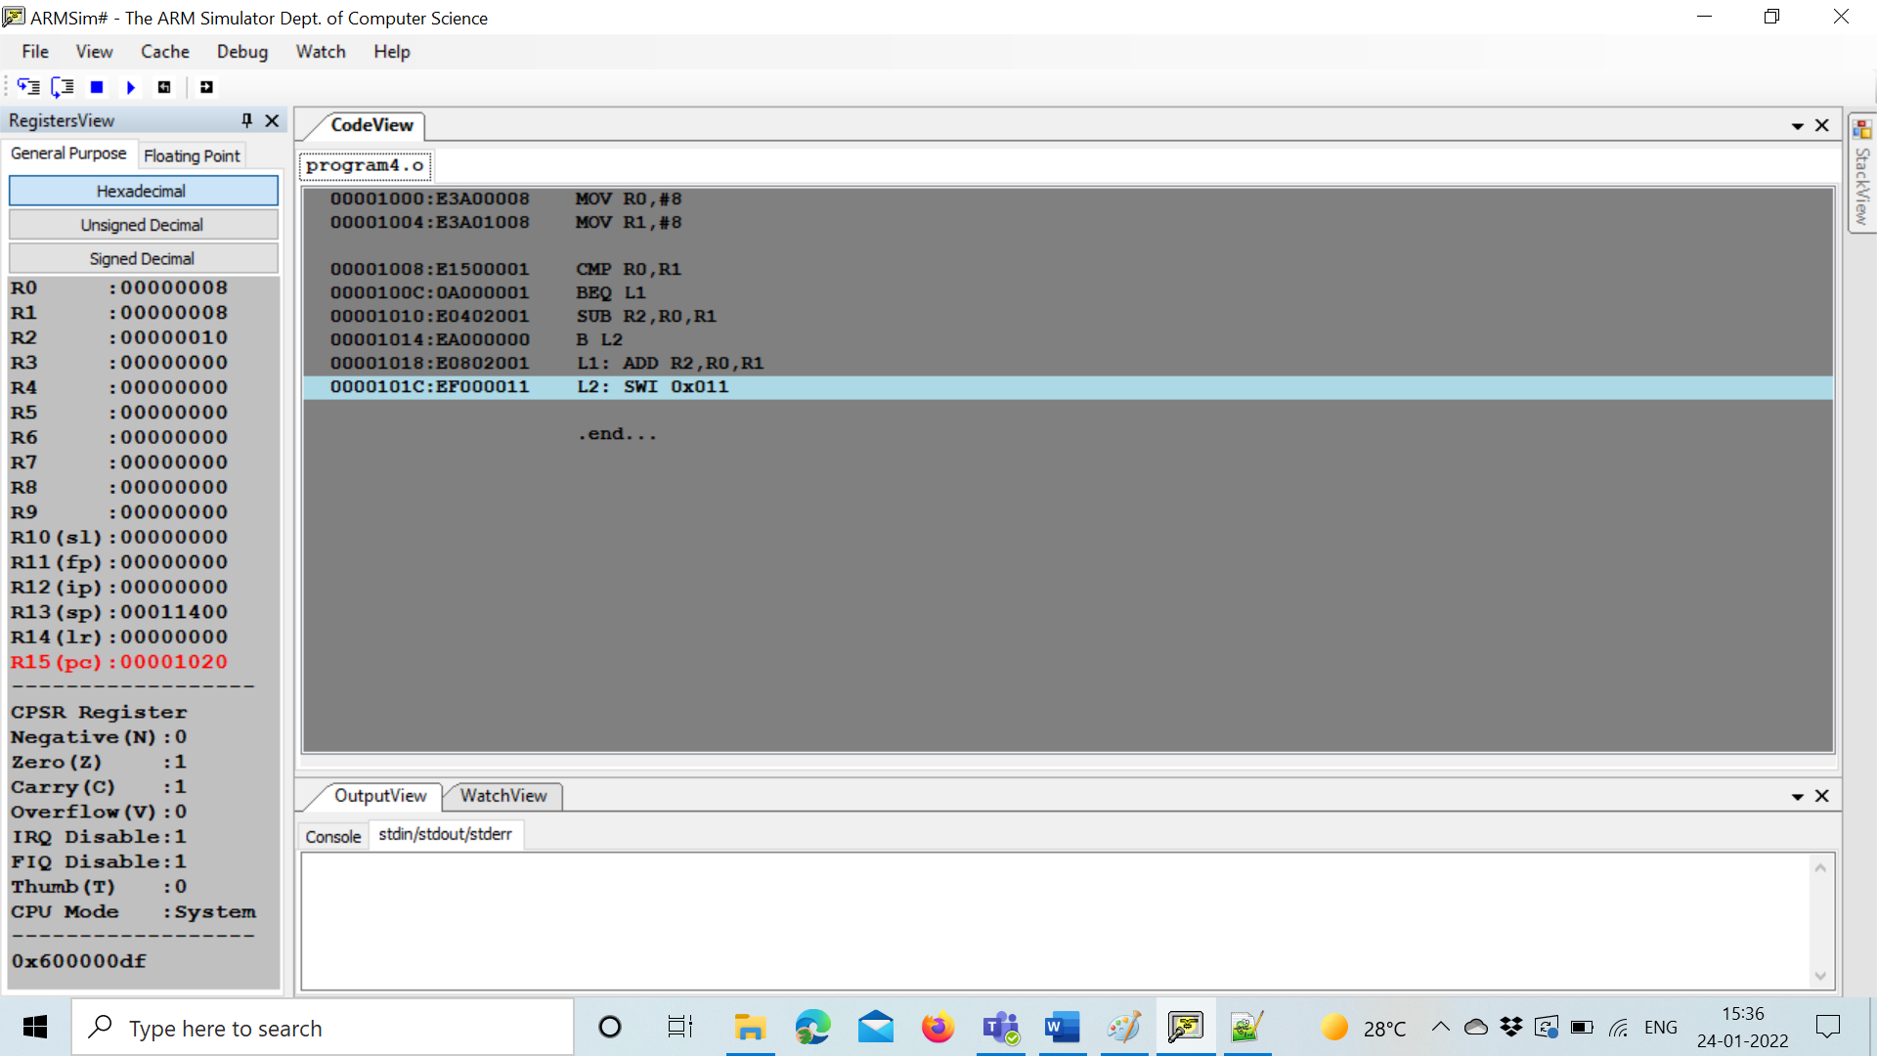

**Disclaimer:**

* The programs and output submitted is duly written, verified and executed by me.
* I have not copied from any of my peers nor from the external resource such as internet.
* If found plagiarized, I will abide with the disciplinary action of the University.

Signature: Naren

Name: Naren Chandrashekhar

SRN: PES2UG20CS216

Section: D

Date: 24/01/2022